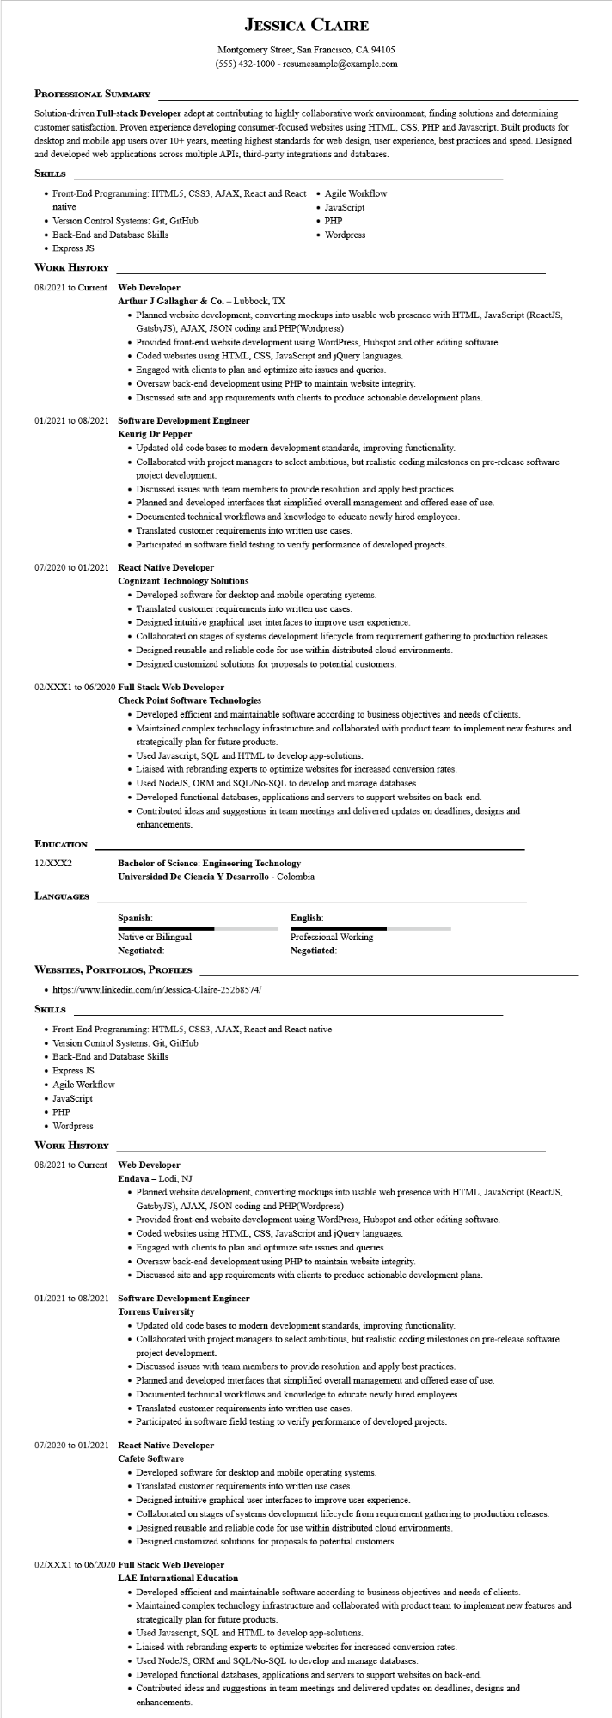
JESSICA CLAIRE
Montgomery Street, San Francisco, CA 94105
(555) 432-1000 - resumesample@example.com
PROFESSIONAL SUMMARY
Solution-driven Full-stack Developer adept at contributing to highly collaborative work environment, finding solutions and determining customer satisfaction. Proven experience developing consumer-focused websites using HTML, CSS, PHP and Javascript. Built products for desktop and mobile app users over 10+ years, meeting highest standards for web design, user experience, best practices and speed. Designed and developed web applications across multiple APIs, third-party integrations and databases.
SKILLS
• Front-End Programming: HTML5, CSS3, AJAX, React and React native
• Version Control Systems: Git, GitHub
• Back-End and Database Skills
• Express JS
WORK HISTORY
• Agile Workflow
• JavaScript
• PHP
• Wordpress
08/2021 to Current Web Developer
Arthur J Gallagher & Co. - Lubbock, TX
• Planned website development, converting mockups into usable web presence with HTML, JavaScript (ReactJS, GatsbyJS), AJAX, JSON coding and PHP(Wordpress)
• Provided front-end website development using WordPress, Hubspot and other editing software.
• Coded websites using HTML, CSS, JavaScript and jQuery languages.
• Engaged with clients to plan and optimize site issues and queries.
• Oversaw back-end development using PHP to maintain website integrity.
• Discussed site and app requirements with clients to produce actionable development plans.
01/2021 to 08/2021 Software Development Engineer
Keurig Dr Pepper
• Updated old code bases to modern development standards, improving functionality.
• Collaborated with project managers to select ambitious, but realistic coding milestones on pre-release software project development.
• Discussed issues with team members to provide resolution and apply best practices.
• Planned and developed interfaces that simplified overall management and offered ease of use.
• Documented technical workflows and knowledge to educate newly hired employees.
• Translated customer requirements into written use cases.
• Participated in software field testing to verify performance of developed projects.
07/2020 to 01/2021 React Native Developer
Cognizant Technology Solutions
• Developed software for desktop and mobile operating systems.
• Translated customer requirements into written use cases.
• Designed intuitive graphical user interfaces to improve user experience.
• Collaborated on stages of systems development lifecycle from requirement gathering to production releases.
• Designed reusable and reliable code for use within distributed cloud environments.
• Designed customized solutions for proposals to potential customers.
02/XXX1 to 06/2020 Full Stack Web Developer
Check Point Software Technologies
• Developed efficient and maintainable software according to business objectives and needs of clients.
• Maintained complex technology infrastructure and collaborated with product team to implement new features and strategically plan for future products.
• Used Javascript, SQL and HTML to develop app-solutions.
• Liaised with rebranding experts to optimize websites for increased conversion rates.
• Used NodeJS, ORM and SQL/No-SQL to develop and manage databases.
• Developed functional databases, applications and servers to support websites on back-end.
• Contributed ideas and suggestions in team meetings and delivered updates on deadlines, designs and enhancements.
EDUCATION
12/XXX2
Bachelor of Science: Engineering Technology
Universidad De Ciencia Y Desarrollo - Colombia
LANGUAGES
Spanish:
Native or Bilingual
Negotiated:
WEBSITES, PORTFOLIOS, PROFILES
• https://www.linkedin.com/in/Jessica-Claire-252b8574/
SKILLS
English:
Professional Working Negotiated:
• Front-End Programming: HTML5, CSS3, AJAX, React and React native
• Version Control Systems: Git, GitHub
• Back-End and Database Skills
• Express JS
• Agile Workflow
• JavaScript
• PHP
• Wordpress
WORK HISTORY
08/2021 to Current Web Developer
Endava - Lodi, NJ
• Planned website development, converting mockups into usable web presence with HTML, JavaScript (ReactJS, GatsbyJS), AJAX, JSON coding and PHP(Wordpress)
• Provided front-end website development using WordPress, Hubspot and other editing software.
• Coded websites using HTML, CSS, JavaScript and jQuery languages.
• Engaged with clients to plan and optimize site issues and queries.
• Oversaw back-end development using PHP to maintain website integrity.
• Discussed site and app requirements with clients to produce actionable development plans.
01/2021 to 08/2021 Software Development Engineer
Torrens University
• Updated old code bases to modern development standards, improving functionality.
• Collaborated with project managers to select ambitious, but realistic coding milestones on pre-release software project development.
• Discussed issues with team members to provide resolution and apply best practices.
• Planned and developed interfaces that simplified overall management and offered ease of use.
• Documented technical workflows and knowledge to educate newly hired employees.
• Translated customer requirements into written use cases.
• Participated in software field testing to verify performance of developed projects.
07/2020 to 01/2021 React Native Developer
Cafeto Software
• Developed software for desktop and mobile operating systems.
• Translated customer requirements into written use cases.
• Designed intuitive graphical user interfaces to improve user experience.
• Collaborated on stages of systems development lifecycle from requirement gathering to production releases.
• Designed reusable and reliable code for use within distributed cloud environments.
• Designed customized solutions for proposals to potential customers.
02/XXX1 to 06/2020 Full Stack Web Developer
LAE International Education
• Developed efficient and maintainable software according to business objectives and needs of clients.
• Maintained complex technology infrastructure and collaborated with product team to implement new features and strategically plan for future products.
• Used Javascript, SQL and HTML to develop app-solutions.
• Liaised with rebranding experts to optimize websites for increased conversion rates.
• Used NodeJS, ORM and SQL/No-SQL to develop and manage databases.
• Developed functional databases, applications and servers to support websites on back-end.
• Contributed ideas and suggestions in team meetings and delivered updates on deadlines, designs and enhancements.

